# BANK LOAN REPORT

**SUMMARY DASHBOARD**

**Total Loan Applications:**

SELECT COUNT(id) AS Total_Loan_Applications FROM bank_loan_data;



**Month to Date Loan Applications :**

SELECT COUNT(id) AS MTD_Total_Loan_Applications FROM bank_loan_data

WHERE MONTH(issue_date) = 12 AND YEAR(issue_date) = 2021;



**Previous Month to Date Applications:**

SELECT COUNT(id) AS PMTD_Total_Loan_Applications FROM bank_loan_data

WHERE MONTH(issue_date) = 11 AND YEAR(issue_date) = 2021;



**Total Funded Amount:**

SELECT SUM(loan_amount) AS Total_Funded_Amount FROM bank_loan_data;



**Month to Date Total Funded Amount:**

SELECT SUM(loan_amount) AS MTD_Total_Funded_Amount FROM bank_loan_data

WHERE MONTH(issue_date) = 12 AND YEAR(issue_date) = 2021;



**Previous Month to Date Total Funded Amount:**

SELECT SUM(loan_amount) AS PMTD_Total_Funded_Amount FROM bank_loan_data

WHERE MONTH(issue_date) = 11 AND YEAR(issue_date) = 2021;



**Total Amount Received:**

SELECT SUM(total_payment) AS Total_Amount_Received FROM bank_loan_data;



**Month to Date Total Amount Received:**

SELECT SUM(total_payment) AS MTD_Total_Amount_Received FROM bank_loan_data

WHERE MONTH(issue_date) = 12 AND YEAR(issue_date) = 2021;



**Previous Month to Date Total Amount Received:**

SELECT SUM(total_payment) AS PMTD_Total_Amount_Received FROM bank_loan_data

WHERE MONTH(issue_date) = 11 AND YEAR(issue_date) = 2021;



**Average Interest Rate:**

SELECT ROUND(AVG(int_rate)*100,2) AS Avg_Interest_Rate FROM bank_loan_data;



**Month to Date Average Interest Rate:**

SELECT ROUND(AVG(int_rate)*100,2) AS MTD_Avg_Interest_Rate FROM bank_loan_data

WHERE MONTH(issue_date) = 12 AND YEAR(issue_date) = 2021;



**Previous Month to Date Average Interest Rate:**

SELECT ROUND(AVG(int_rate)*100,2) AS PMTD_Avg_Interest_Rate FROM bank_loan_data

WHERE MONTH(issue_date) = 11 AND YEAR(issue_date) = 2021;



**Average DTI:**

SELECT ROUND(AVG(dti)*100,2) AS Avg_DTI FROM bank_loan_data;



**Month to Date Average DTI:**

SELECT ROUND(AVG(dti)*100,2) AS MTD_Avg_DTI FROM bank_loan_data

WHERE MONTH(issue_date) = 12 AND YEAR(issue_date) = 2021;



**Previous Month to Date Average DTI:**

SELECT ROUND(AVG(dti)*100,2) AS PMTD_Avg_DTI FROM bank_loan_data

WHERE MONTH(issue_date) = 11 AND YEAR(issue_date) = 2021;



**GOOD LOANS**

**Good Loan Percentage:**

SELECT

(COUNT(CASE WHEN loan_status = 'Fully Paid' OR loan_status='Current' THEN id END)*100.0)

/

COUNT(id) as Per_Good_Loan

FROM bank_loan_data;



**Good Loan Applications:**

SELECT COUNT(id) AS Good_Loan_Applications FROM bank_loan_data

WHERE loan_status = 'Fully Paid' OR loan_status='Current';



**Good Loan Funded Amount:**

SELECT SUM(loan_amount) AS Good_Loan_Funded_Amount FROM bank_loan_data

WHERE loan_status IN ('Fully Paid','Current');



**Good Loan Total Amount Received:**

SELECT SUM(total_payment) AS Good_Loan_Amount_Received FROM bank_loan_data

WHERE loan_status IN ('Fully Paid','Current');



**BAD LOANS**

**Bad Loan Percentage:**

SELECT

(COUNT(CASE WHEN loan_status = 'Charged Off' THEN id END)*100.0)

/

COUNT(id) as Per_Bad_Loan

FROM bank_loan_data;



**Bad Loan Applications:**

SELECT COUNT(id) AS Bad_Loan_Applications FROM bank_loan_data

WHERE loan_status = 'Charged Off';



**Bad Loan Funded Amount:**

SELECT SUM(loan_amount) AS Bad_Loan_Funded_Amount FROM bank_loan_data

WHERE loan_status = 'Charged Off';



**Bad Loan Total Amount Received:**

SELECT SUM(total_payment) AS Bad_Loan_Amount_Received FROM bank_loan_data

WHERE loan_status = 'Charged Off';



**Grid Views:**

SELECT loan_status,COUNT(id) AS LoanCount, SUM(total_payment) AS Total_Amount_Received,

SUM(loan_amount) AS Total_Funded_Amount, AVG(int_rate*100) AS Interest_Rate, AVG(dti*100) AS DTI

FROM bank_loan_data

GROUP BY loan_status;

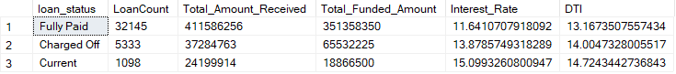

SELECT loan_status,

SUM(total_payment) AS MTD_Total_Amount_Received,

SUM(loan_amount) AS MTD_Total_Loan_Funded

FROM bank_loan_data

WHERE MONTH(issue_date)=12

GROUP BY loan_status;

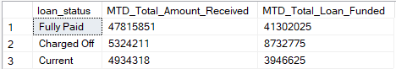

**OVERVIEW DASHBOARD**

**Monthly Trends:**

SELECT Month(issue_date) AS Month_Number,

DATENAME(MONTH,issue_date)AS Month_Name,

COUNT(id) AS Total_Loan_Applications,

SUM(loan_amount) as Total_Funded_Amount,

SUM(total_payment)as Total_Received_Amount

FROM bank_loan_data

GROUP BY DATENAME(MONTH,issue_date),Month(issue_date)

ORDER BY Month(issue_date);

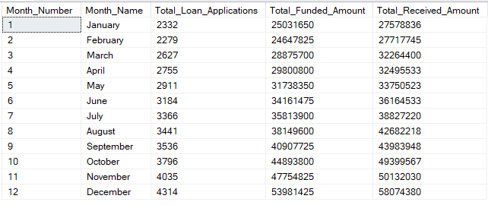

Regional Trends:

SELECT address_state,

COUNT(id) AS Total_Loan_Applications,

SUM(loan_amount) as Total_Funded_Amount,

SUM(total_payment)as Total_Received_Amount

FROM bank_loan_data

GROUP BY address_state

ORDER BY SUM(loan_amount)DESC;

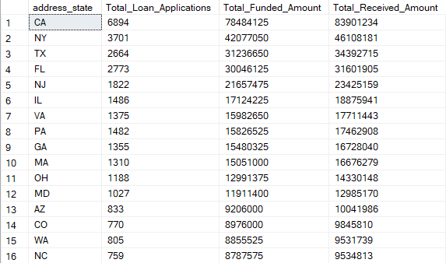

Loan Term Trends:

SELECT term,

COUNT(id) AS Total_Loan_Applications,

SUM(loan_amount) as Total_Funded_Amount,

SUM(total_payment)as Total_Received_Amount

FROM bank_loan_data

GROUP BY term

ORDER BY term;



EMPLOYEE LENGTH TRENDS:

SELECT emp_length,

COUNT(id) AS Total_Loan_Applications,

SUM(loan_amount) as Total_Funded_Amount,

SUM(total_payment)as Total_Received_Amount

FROM bank_loan_data

GROUP BY emp_length

ORDER BY COUNT(id) DESC;

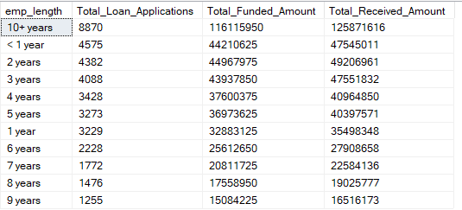

**PURPOSE TRENDS:**

**SELECT purpose,**

COUNT(id) AS Total_Loan_Applications,

SUM(loan_amount) as Total_Funded_Amount,

SUM(total_payment)as Total_Received_Amount

FROM bank_loan_data

GROUP BY purpose

ORDER BY COUNT(id) DESC;

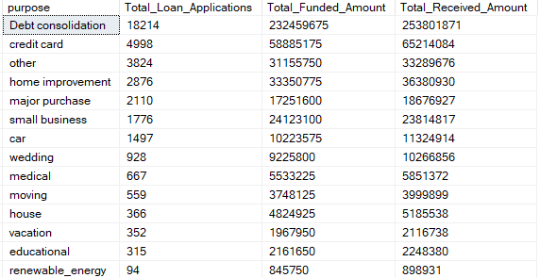

**House Ownership Trends:**

SELECT home_ownership,

COUNT(id) AS Total_Loan_Applications,

SUM(loan_amount) as Total_Funded_Amount,

SUM(total_payment)as Total_Received_Amount

FROM bank_loan_data

GROUP BY home_ownership

ORDER BY COUNT(id) DESC;



